FAGLL03-G/L LINE ITEM DISPLAY - FOR GR/IR OFFSET ENTRIES


This simulation describes how to use T-Code FAGLL03 to display entries posted from GR/IR Offset Framework solution in Statutory or/and Tax Ledgers depending on the GR/IR offset requirements from the entities in scope.

Click to continue.

Explanation | Screenshot
[1] FAGLL03 is now entered in the Transaction box. | 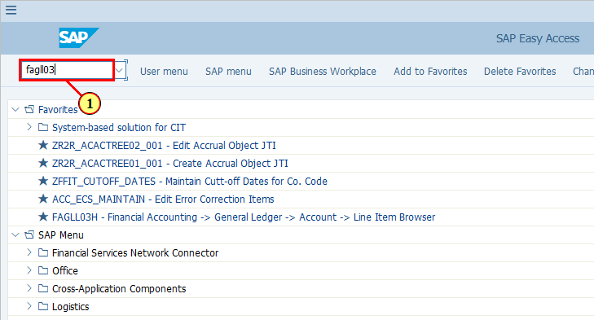
[2] The G/L account field is filled out.    For GR/IR Offset solution, two purposely defined G/L accounts are used:  - 246027 - for GR offset  - 246028 - for IR offset and reposting  Therefore we will need to display these two accounts to see the G/L line items from GR/IR offset solution. | 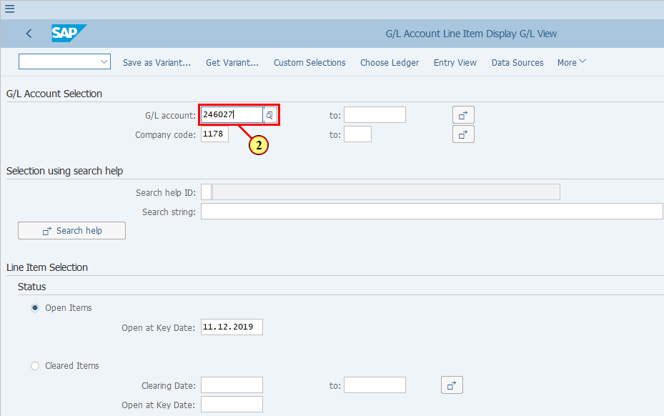
[3] The to field is filled out. | 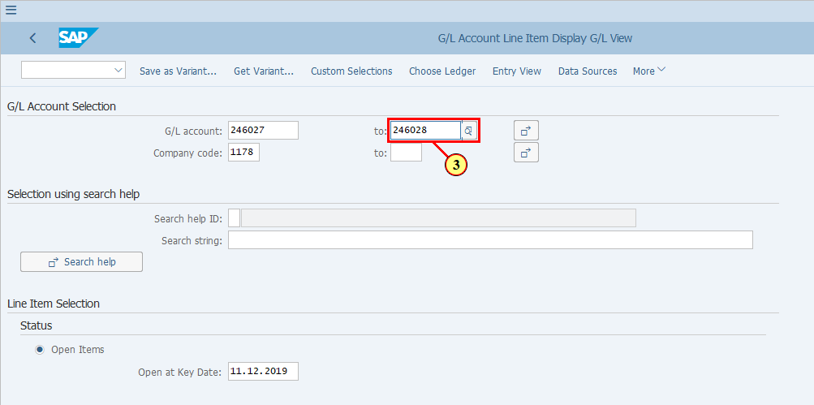
[4] We will display All Items to see the overall postings. You may also display Open Items if you wish to see only the open items or you are investigating specific cases in whch you do not wish to see all the postings.  All Items is now selected. | 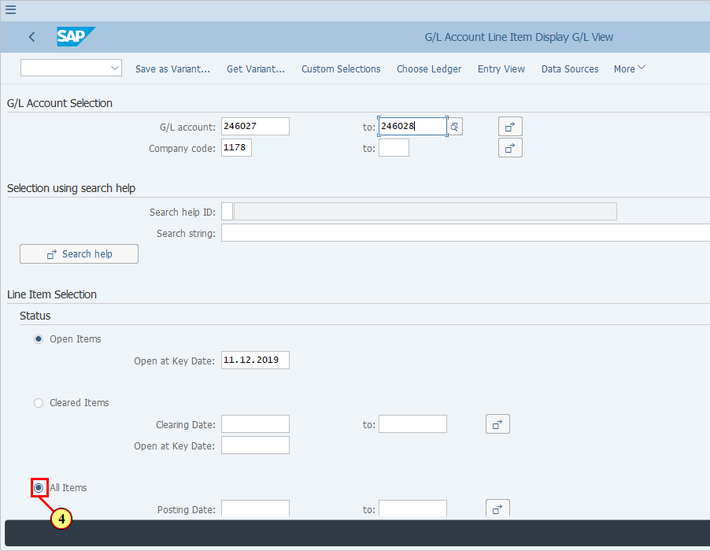
[5] Enter a Posting Date range. | 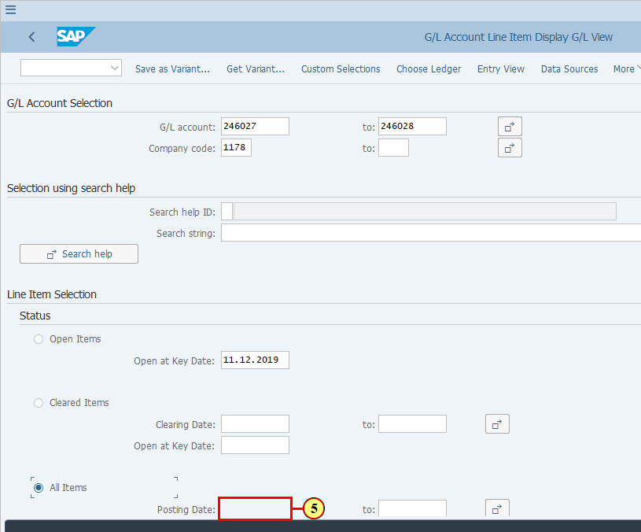
[6] The to field is filled out. | 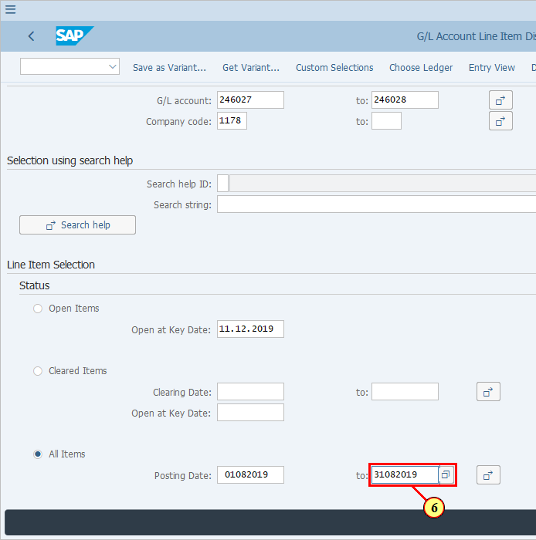
[7] Click Choose Ledger .  You can also press Ctrl+F3. | 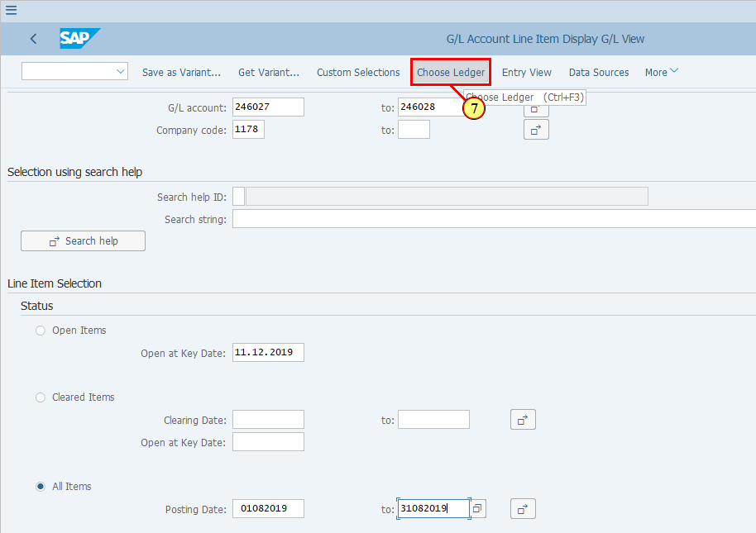
  Please choose the ledger in which your GR/IR Offset solution is activated. This was based on the scope defined in S4F project.  [8] The *Ledger field is filled out. | 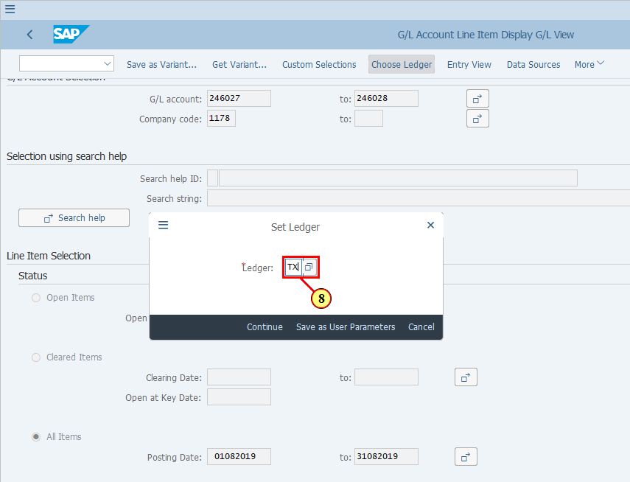
[9] Click Continue .  You can also press Enter. | 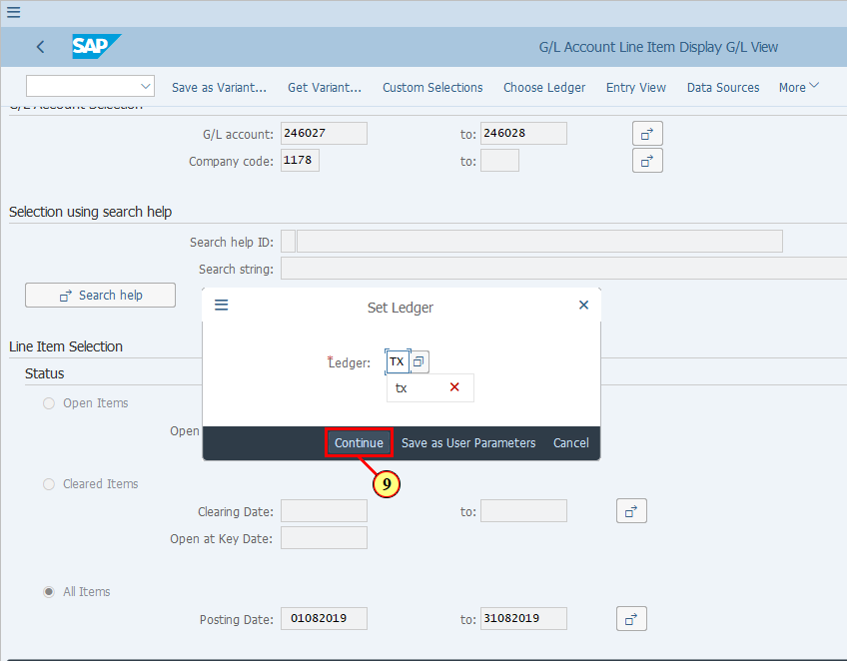
[10] Click Execute .  You can also press F8. | 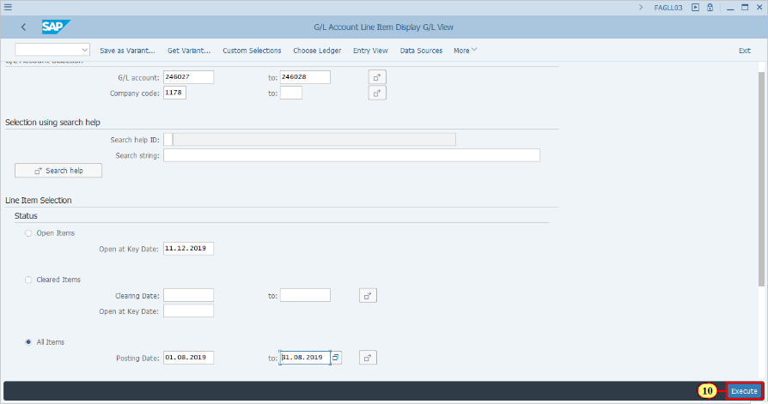
  You may wish to create a layout for checking GR/IR offset line items. Your layout should include the key columns that are shown on this screenshot, so that you can calculate subtotals based on Assignment field, which reflect the PO+Item number.  We will continue to explain what to look for in these line items. | 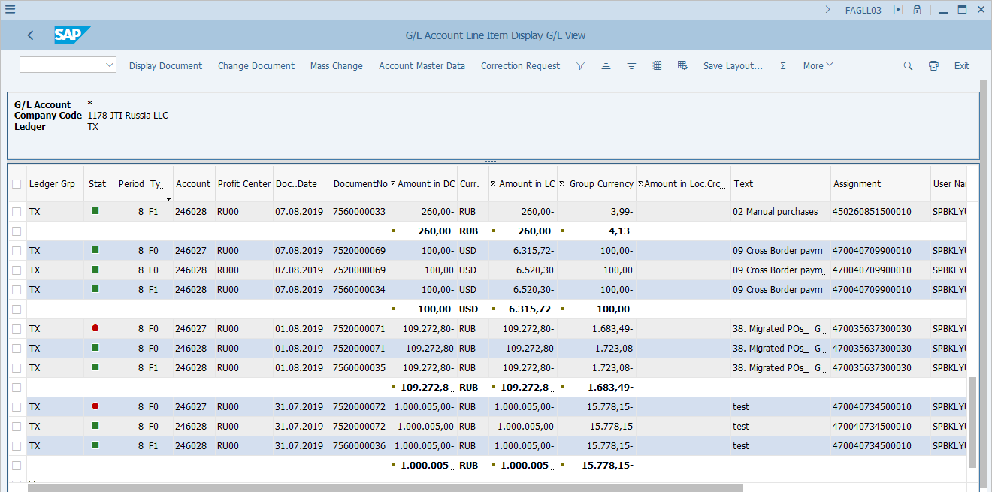
  From this report you can display details of the respective accounting documents.  Let's pick up a document posted to GL 246027 with document type F0 - specific GR/IR offset document type.  [11] Click Account . | 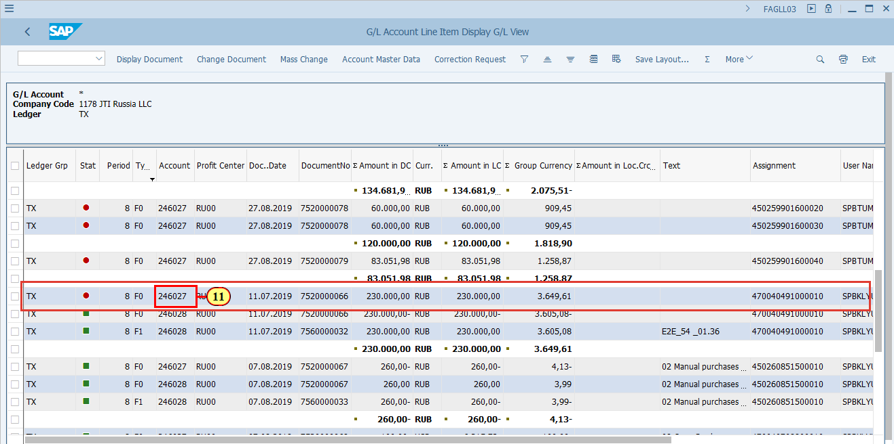
[12] Click Display Document .  You can also press Ctrl+Shift+F7. | 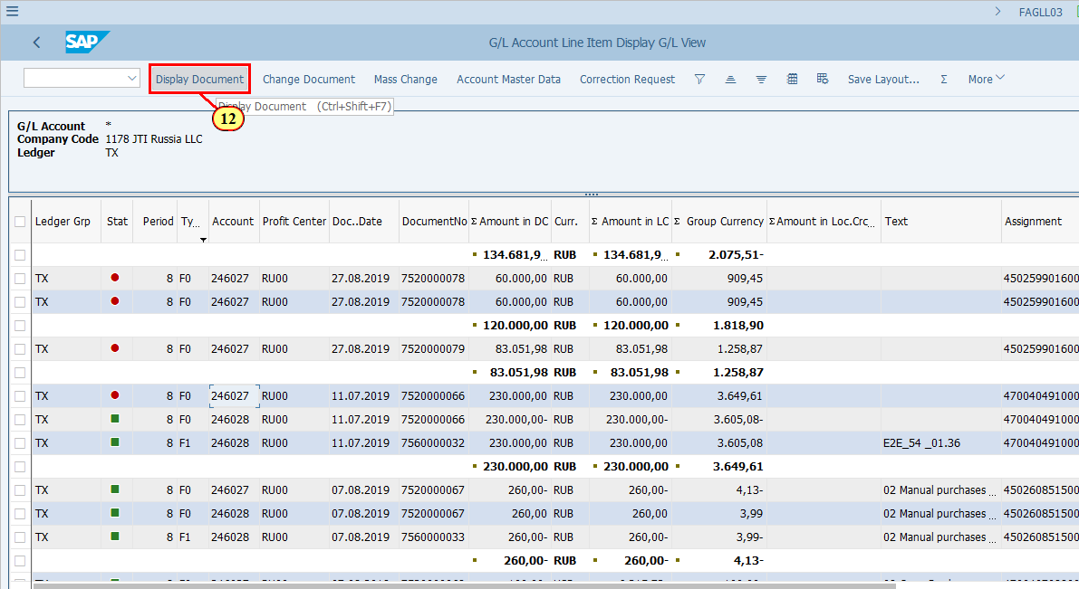
[13] Click Call Up Document Overview .  You can also press F9. | 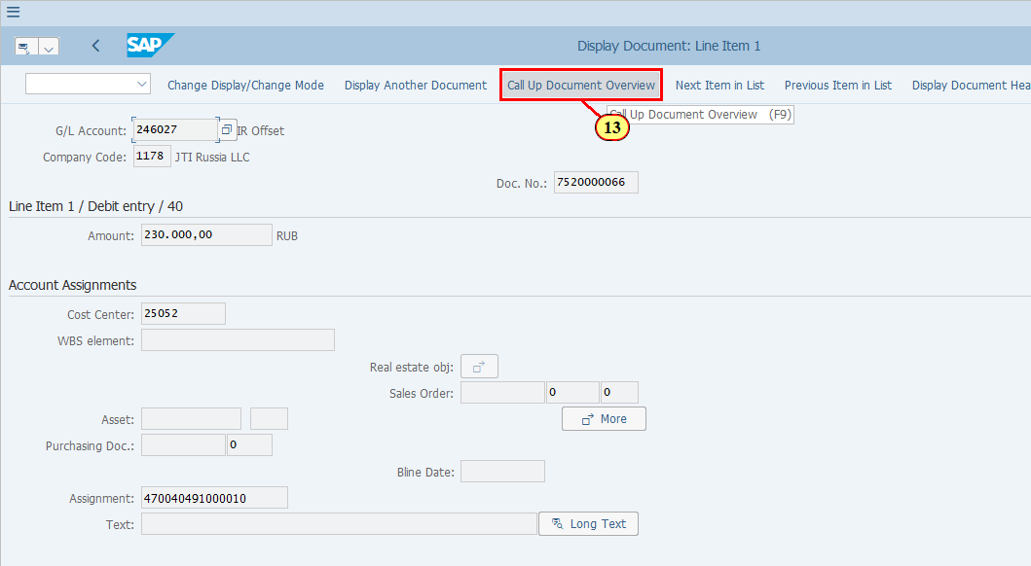
  This is an IR offset document as you can see that IR offset was posted between 246027 and 246028, with PPV also offset.  Also take note of the Ledger Group.  You may use all FB03 functionalities on this screen.  [14] Click Back .  You can also press F3. | 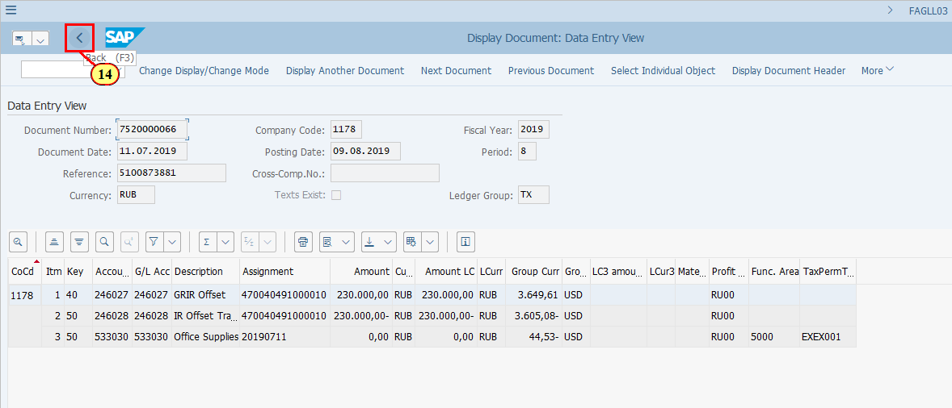
  Let's look at another document also posted for G/L 246027 with Document Type F0.  [15] Click DocumentNo . | 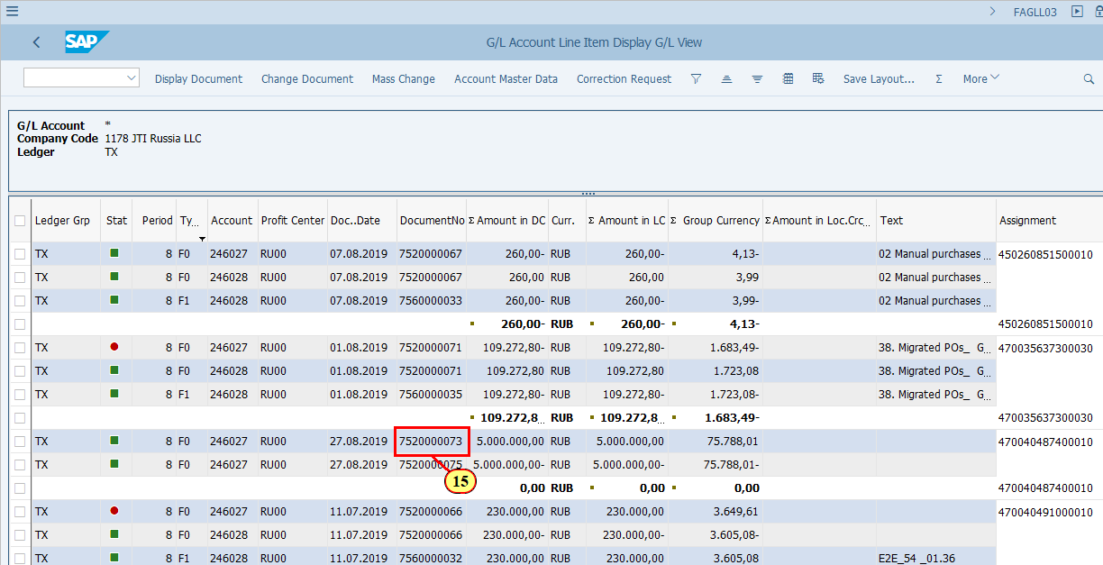
[16] Click Display Document .  You can also press Ctrl+Shift+F7. | 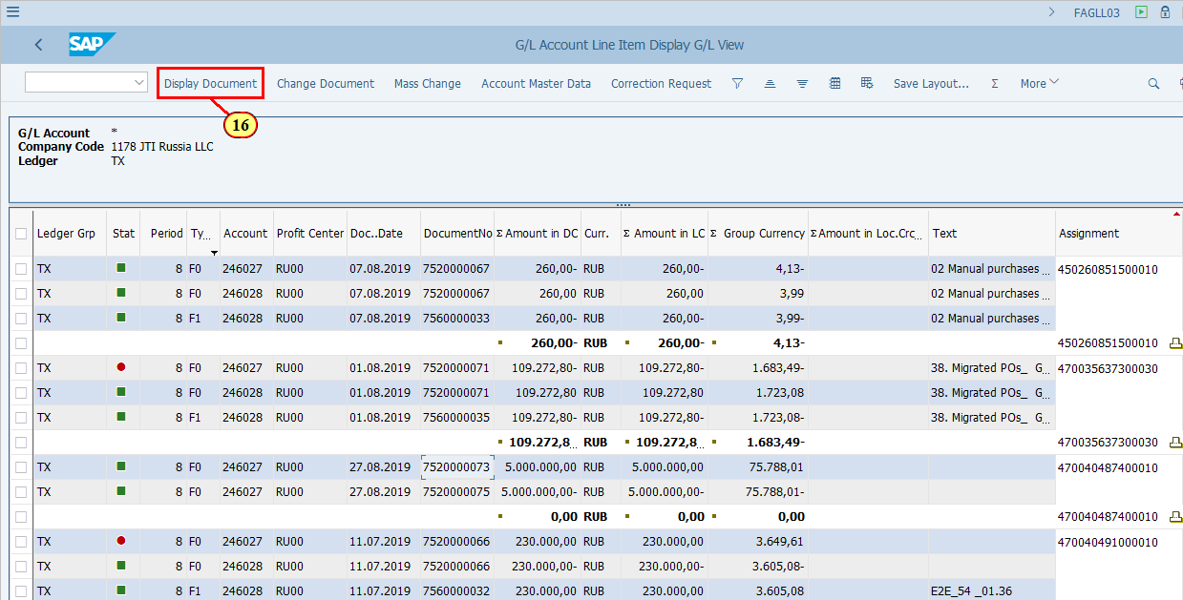
[17] Click Call Up Document Overview .  You can also press F9. | 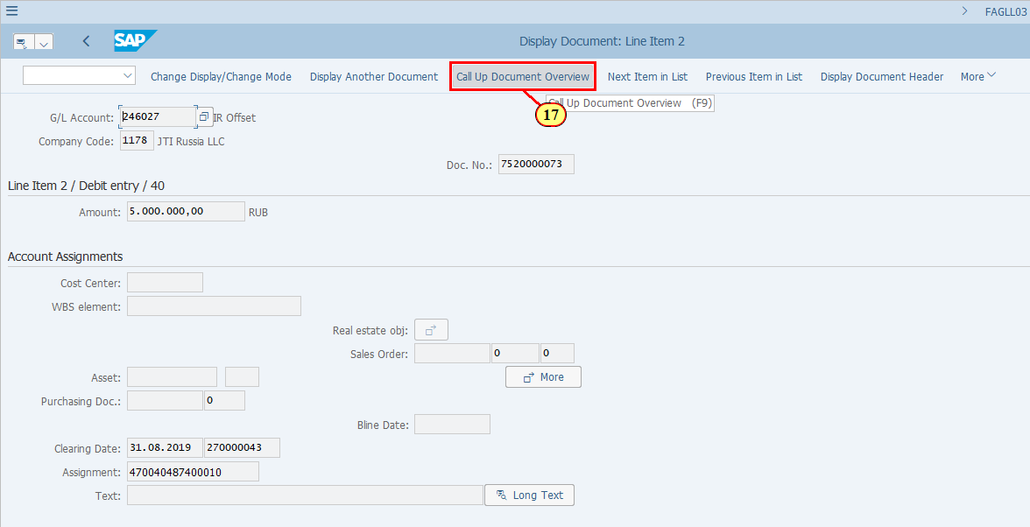
  This is a GR offset document as you can see that GR (expense account) was offset against 246027..  Also take note of the Ledger Group.  You may use all FB03 functionalities on this screen.  [18] Click Back .  You can also press F3. | 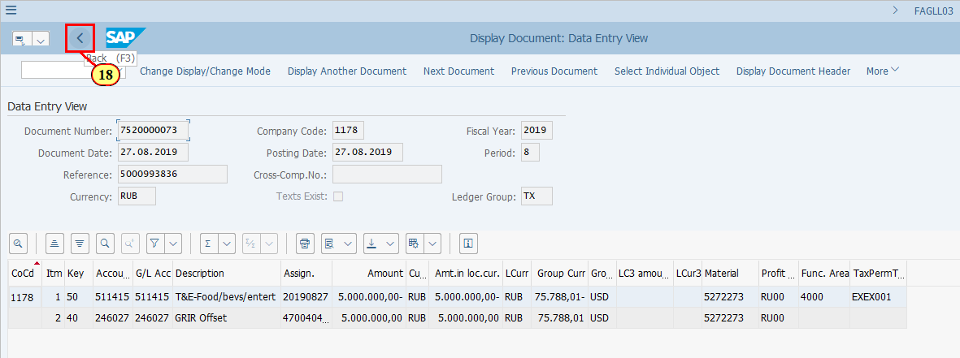
  Now let's have a look at this particular PO item.  Please note that both G/L 246027 and 246028 are totalled to zero in this example.  Now let's display these documents.  [19] Click Doc..Date . | 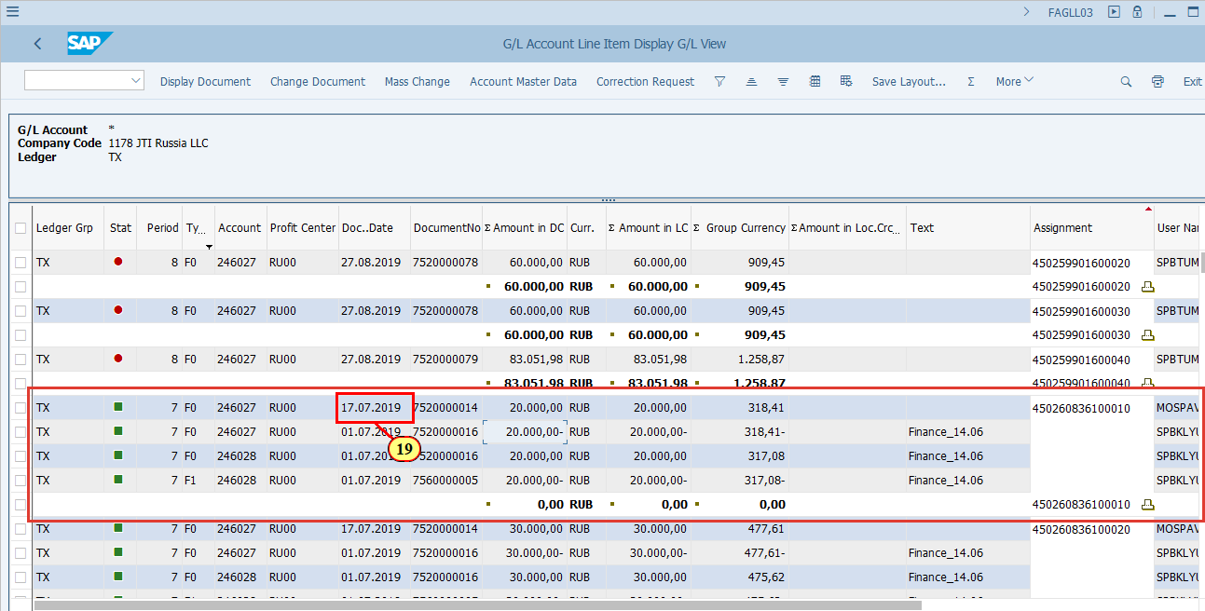
[20] Click Display Document .  You can also press Ctrl+Shift+F7. | 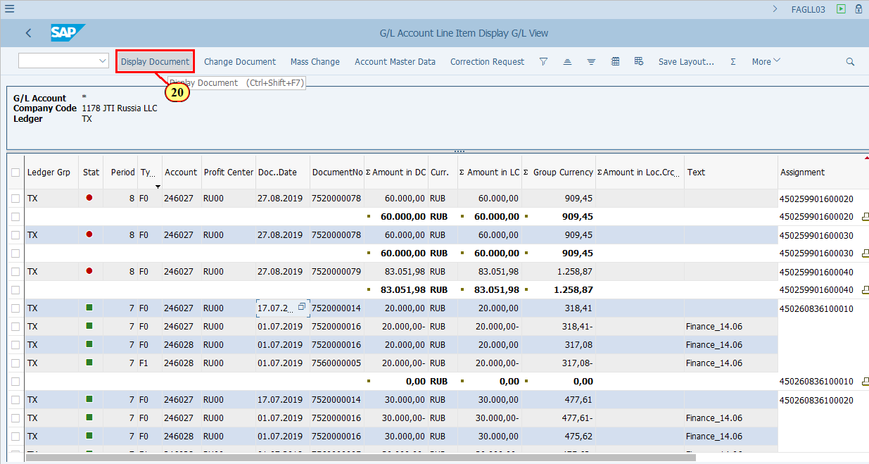
[21] Click Call Up Document Overview .  You can also press F9. | 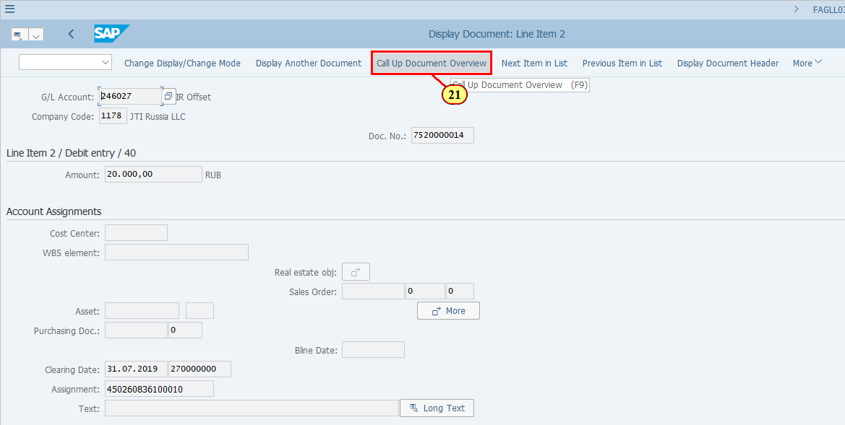
  This is a GR offset document as you can see that GR (expense account) was offset against 246027. There are two PO items included in this document.  Also take note of the Ledger Group.  You may use all FB03 functionalities on this screen.  [22] Click Back .  You can also press F3. | 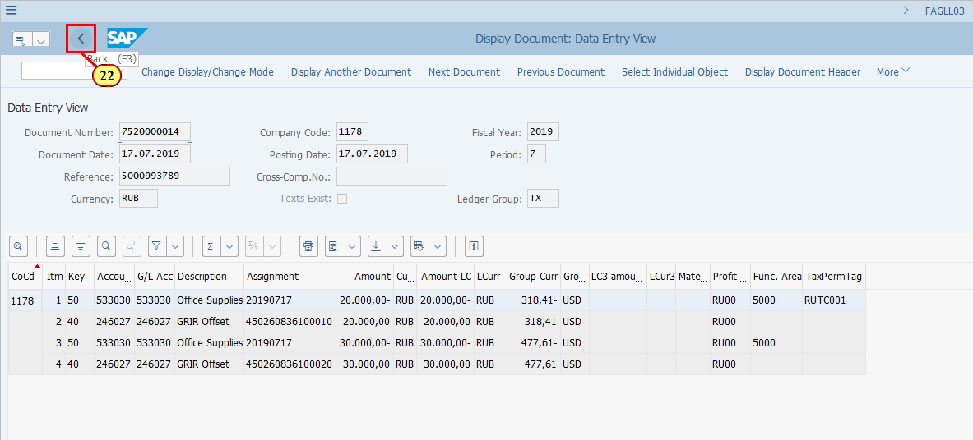
[23] Click Doc..Date . | 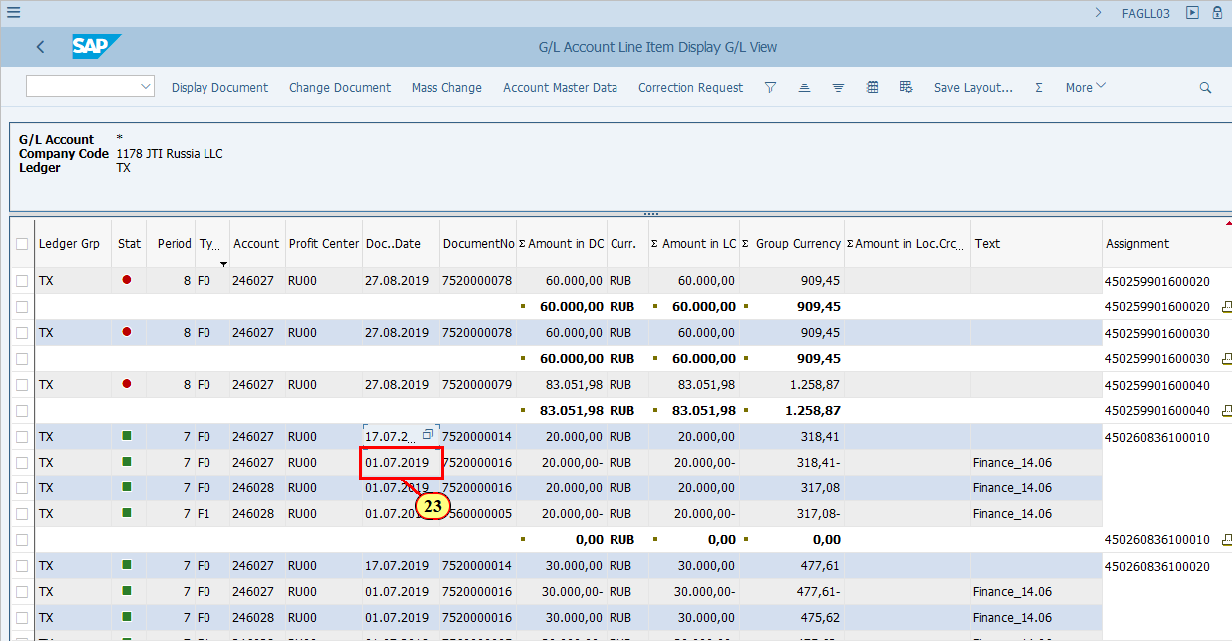
[24] Click Display Document .  You can also press Ctrl+Shift+F7. | 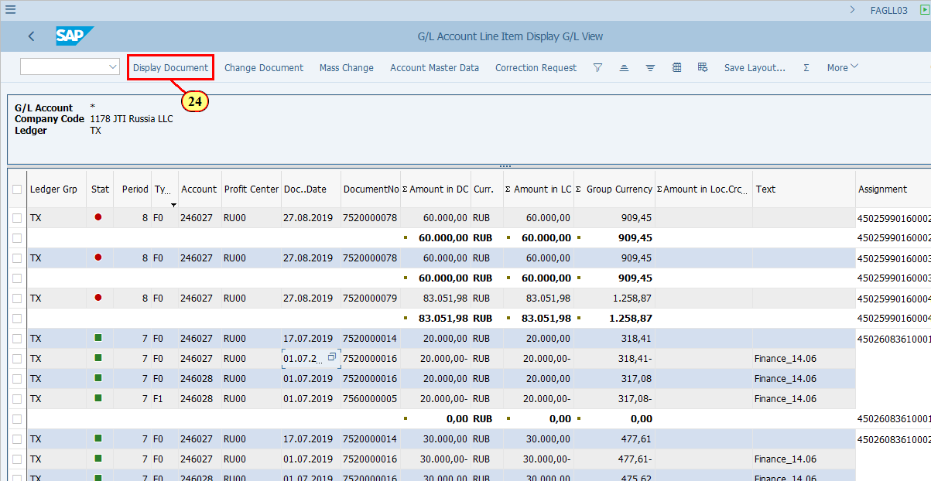
[25] Click Call Up Document Overview .  You can also press F9. | 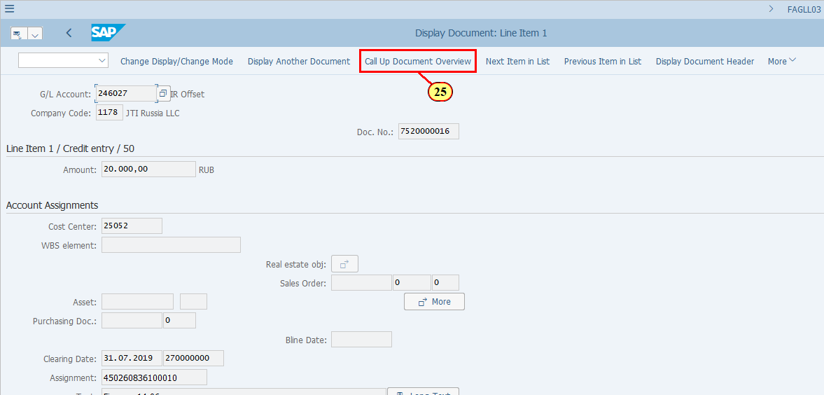
  This is a IR offset document as you can see posted between 246027 and 246028, with some PPV. There are two PO items included in this document.  Also take note of the Ledger Group.  You may use all FB03 functionalities on this screen.  [26] Click Back .  You can also press F3. | 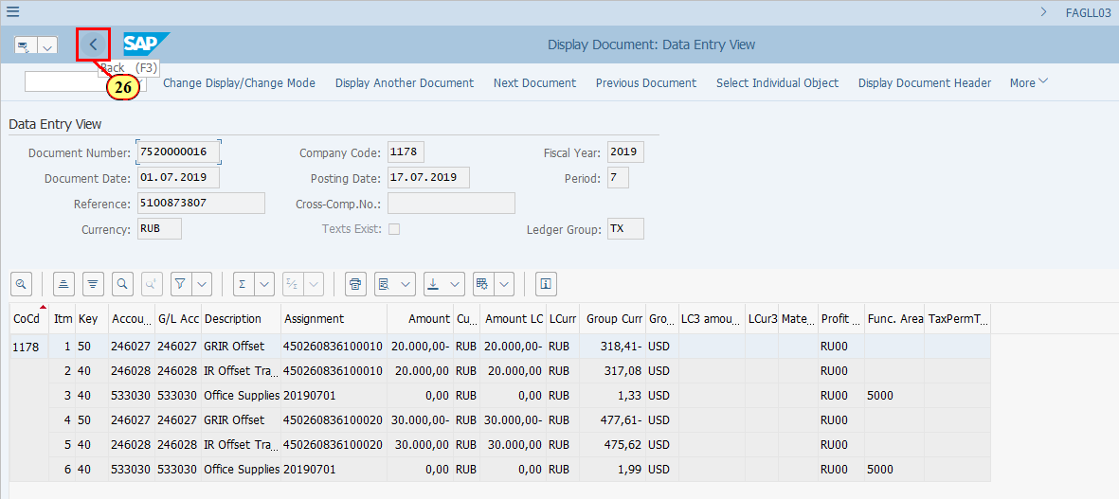
[27] Click DocumentNo . | 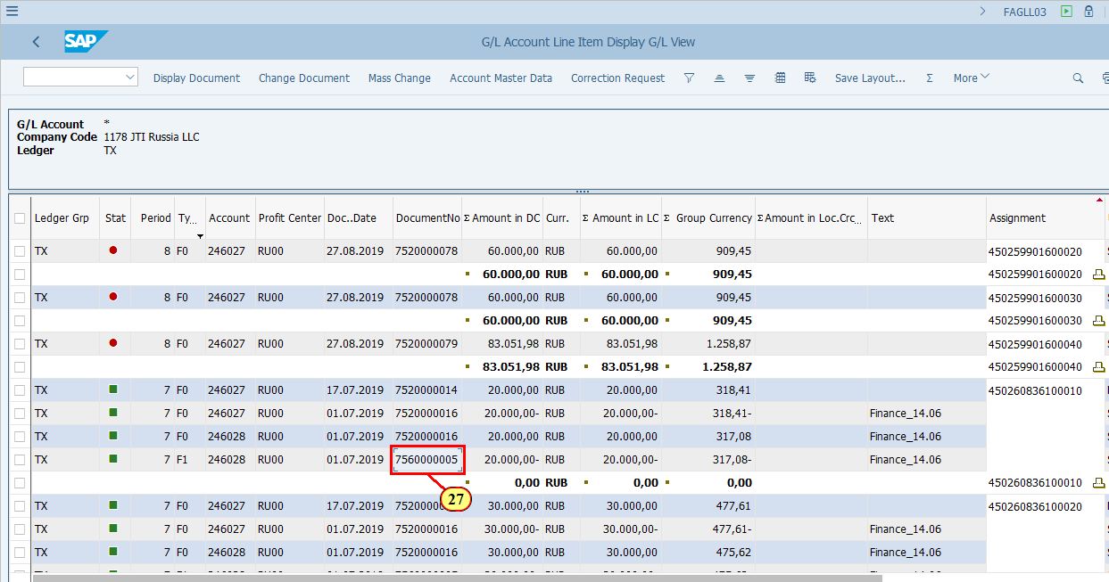
[28] Click Display Document .  You can also press Ctrl+Shift+F7. | 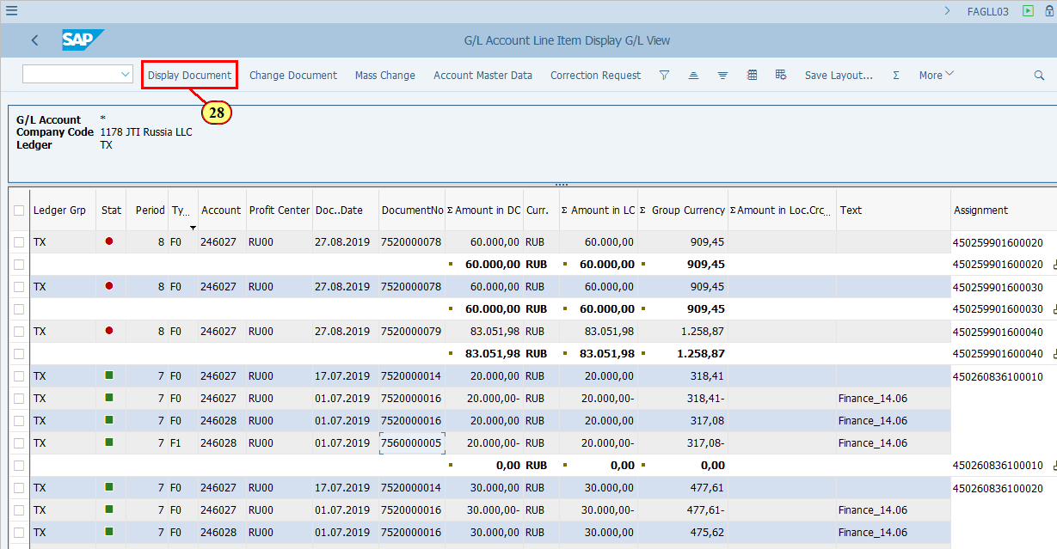
[29] Click Call Up Document Overview .  You can also press F9. | 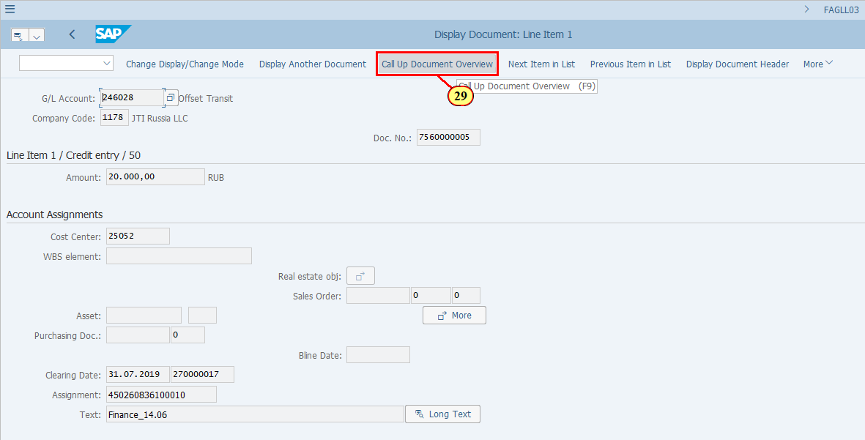
  This is a IR reposting document as you can see posted between expense accounts and 246028, including PPV amout. There are two PO items included in this document.  Also take note of the Ledger Group.  You may use all FB03 functionalities on this screen.  We will now take a look at the Document Header of the IR Reposting document.  [30] Click Display Document Header .  You can also press F5. | 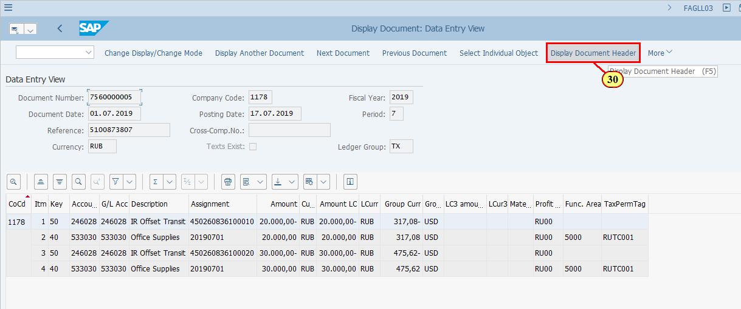
  - The IR Reposting Documents have Document Type F1.  - Every GR/IR Offset document has a Reference number which is the original GR or IR document. In this example for IR Reposting, the Reference number is the original Invoice posting, which was posted via MIRO to all ledgers.  [31] Click Close . | 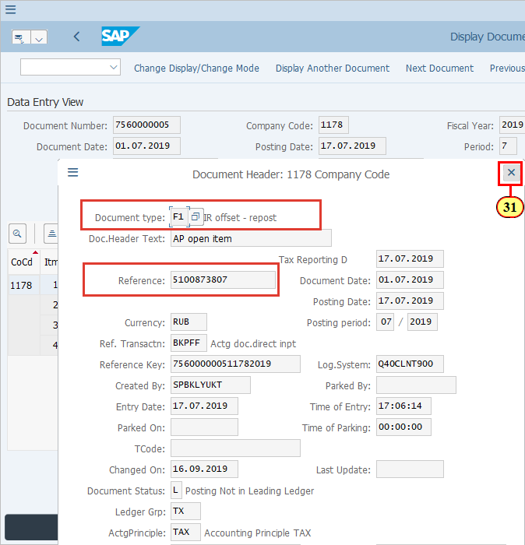
[32] Click Back .  You can also press F3. | 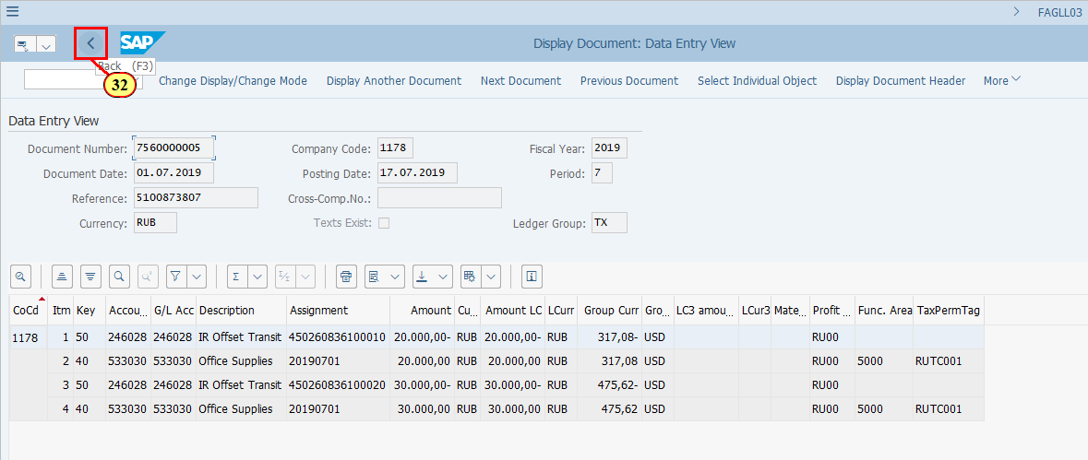
  For a holistic review of GR/IR offset postings, you may check the following (details are described in the training presentation of GR/IR Offset Framework):  - Subtotal of G/L 246028 by PO Item (field Assignment). This should always be zero as one entry is posted for IR Offset and the opposite entry is posted by IR Reposting.  - Subtotal of G/L 246027 by PO Item (field Assignment). This should be zero when both GR and IR are posted for a PO item.  [33] To review for a single account we can use the Filter function.  Click Account . | 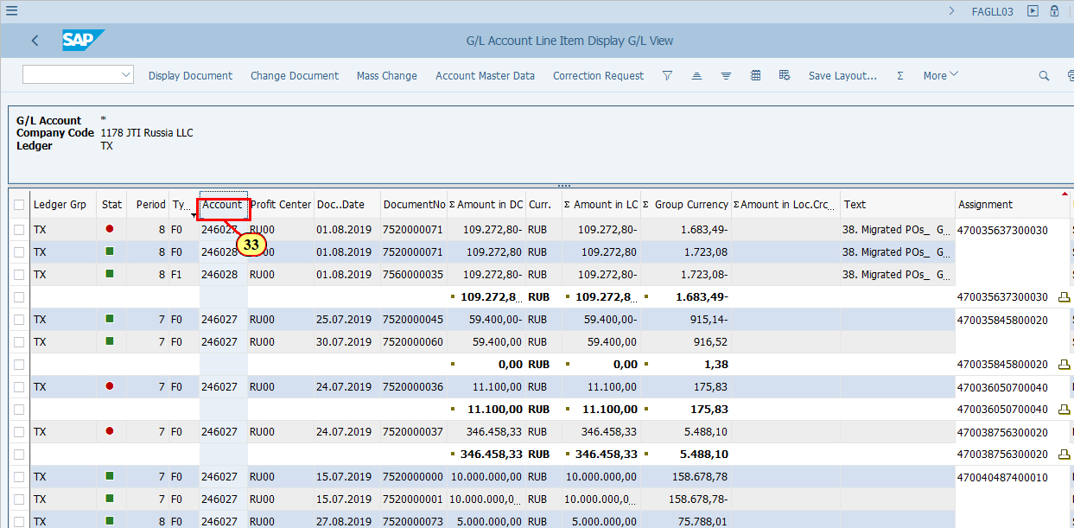
[34] Click Set Filter .  You can also press Ctrl+Shift+F2. | 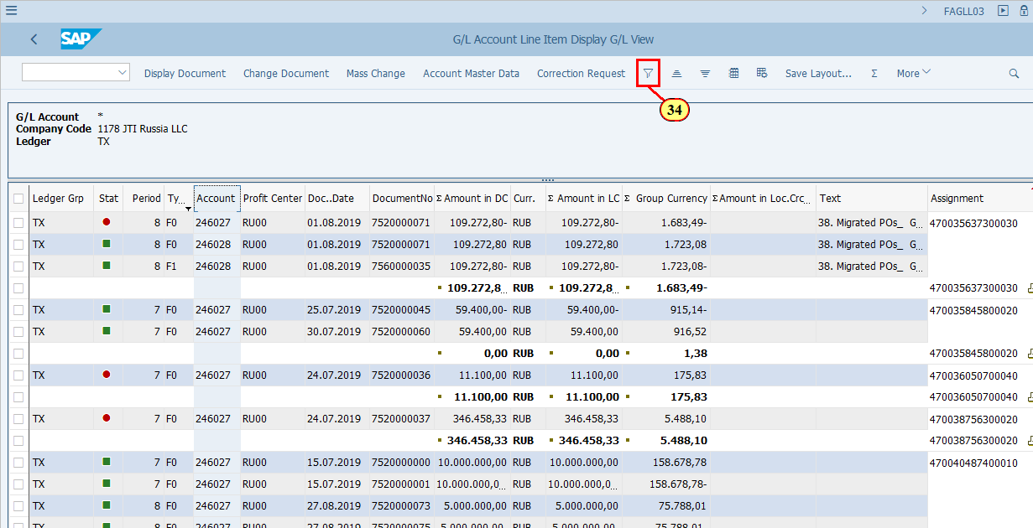
[35] The Account field is filled out. | 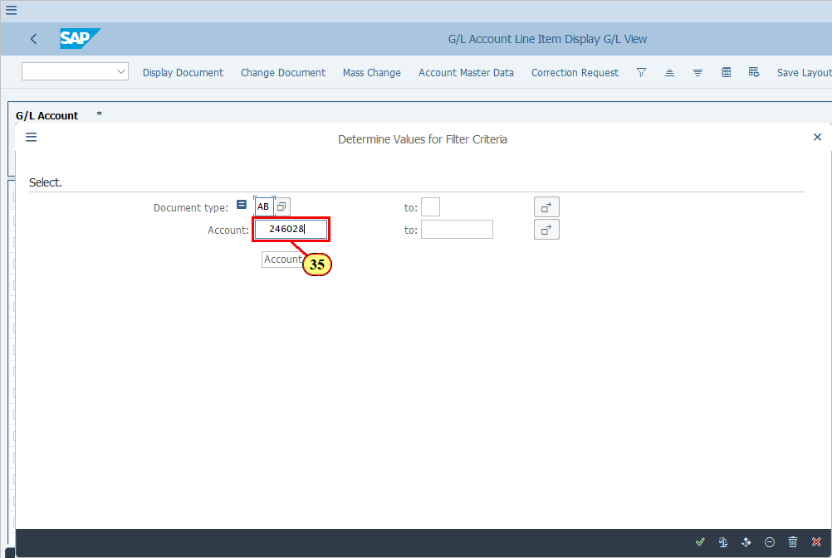
[36] Click Execute .  You can also press Enter. | 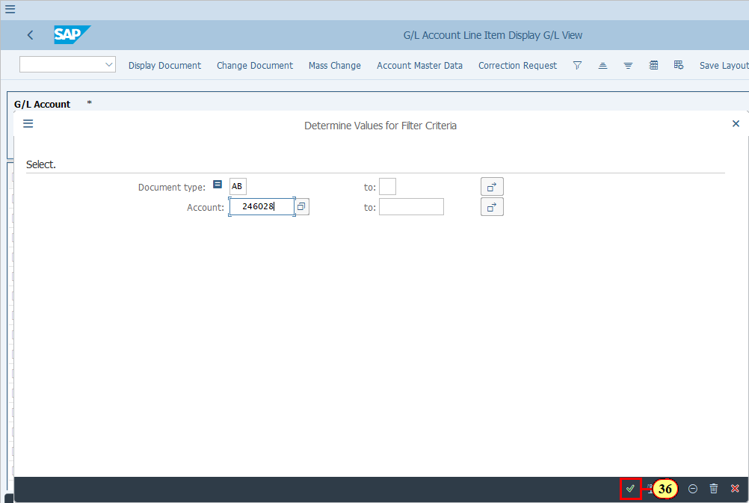
[37] Click Ledger Grp . | 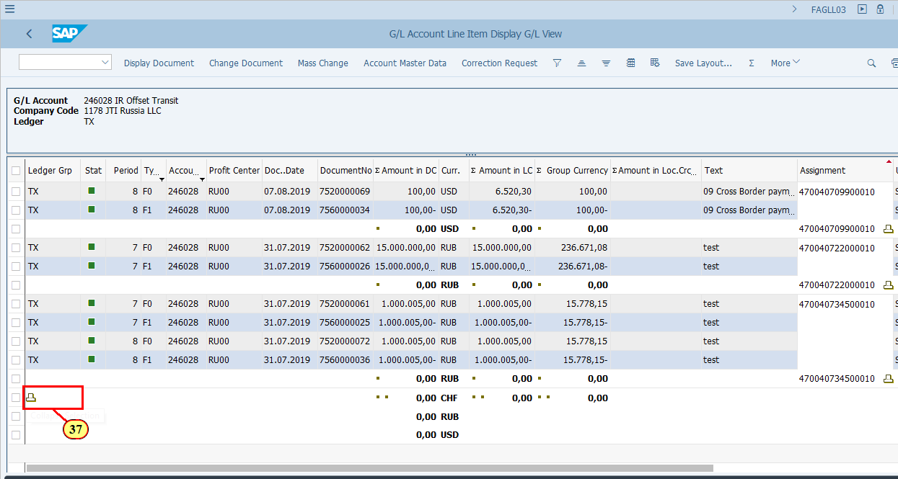
  As you can see that when we subtotal G/L 246028 by Assignment, we have zero for all the PO items.  You may try the same for G/L 246027.  You may perform the same review for all the ledgers that are subject to GR/IR offset (ST and/or TX). | 